VIETNAM SEAPORTS ASSOCIATION (VPA)
REPORT OF THE 8TH EXECUTING COMMITTEE
AT THE ANNUAL MEETING 2017
September 14, 2017 – Da Nang City

GENERAL ASSESSMENT
Following the general assessment, the economic situation of Vietnam during 2016 - 2017 and beyond shall continue to grow as expected at around 6.5%. However, the global trade is not yet fully recovered, particularly in shipping. Cargo going through the ports, including container increased slightly at 5.4% in volume but higher in value in 2016, and regained higher growth in the first half of 2017, at around 9% compared to 2016.

Volume of import/export cargo through VPA ports in 2016 was about 241 million tonnes (5,4% increase compared to 2015), in which, container volume is about 11,5 million TEU (3,5% increase). Volume of container going through the ports in the first half of 2017 increased faster (6%) compared to the same period last year. In general, global and regional shipping is slowing down affecting Vietnam but higher growth for Vietnam is realistic should there be no major unexpected disturbance. Under such environment, the situation of the ports in the country recently has some noticeable development as follows:

The ports have undergone the equitization process with changes in equity sharing, organization, management and operations toward higher efficiency under the competitive market mechanism. Many port enterprises have been listed successfully and attracted additional capital investment for higher development. The port enterprises with controlling stake by the State have also been forced to follow the trend of reform to compete and develop. In particular, Saigon New Port has successfully developed many large port projects together with support service facilities country wide yet experienced difficulty in throughput capacity and inter-connections at the deep water terminals in Cai Mep area as well as increased traffic congestion at Cat Lai terminal in HCMC.

Cargoes going through the ports in three regions grew slower than the previous year with the market shares occupied by the ports as follows: the ports in the North 21.9%, in the Central Area 11.65%; in the Mekong Delta 2.83%; in contrary, cargo through port group no. 5 grew faster to a total market share of 63.6%, in which 43.8% market share for HCMC and Dong Nai, 19.8% for CMTV area.

In CMTV deep water port area, container volume in 2016 increased by only 10%, much slower than 34% growth rate of last year; in first half of 2017 the 10% increase is maintained, while container going through the ports in HCMC area increased by 2.5%. This indicated that container is being attracted slowly at half the speed to large container vessels in CMTV perhaps due to difficulties in berthing windows for large ships and transfer of container between the terminals. In the mean time, it as also difficult to have a long term solution for the traffic congestion at Cat Lai, HCMC. The major obstacle for trade development in general and ports development in particular remains the shortage of deep water ports with proper hinterland connections. There are more than 80% of import/export containerized cargo of Vietnam (more than 8 million TEU/year) is forced to use ports and small vessels with the estimated opportunity loss of around 1.6 billion USD annually, as the burden of Vietnamese shippers mainly, by failing to utilize the larger vessels available on the market. The total throughput capacity of the deep water terminals at CMTV today combining with the expected capacity of Lach Huyen terminals up to 2020 is still not enough to meet such demand.

In addition to containerized cargo, bulk cargo and other type of cargoes using larger vessels going through CMTV area have also increased significantly and accounted for half of the total 48 million tons of cargo throughput of CMTV ports in 2016.

In HCMC, from the beginning of 2016, the congestion in container and difficult trucking at Cat Lai port has exerted pressure for transition of container traffic to Hiep Phuoc area with Soai Rap channel being dredged deeper. However, the capacity to sustainably maintain and increase the depth of Soai Rap channel is yet to be determined coupling with the pressure to introduce larger feeder vessels for intra Asia trade has signaled the safer reallocation of container to the deep water ports in CMTV. HCMC is facing difficulties in assessing the scope and feasibility of the long term port development for the city, including Hiep Phuoc port group, following the market demand and development trend of the whole port group no. 5, through CMTV gateway port.

In Hai Phong area, although the market dimension is significant (more than 3 million TEU/year), but due to limited channel depth, existing large vessels of the shipping lines have not been able to put in use. In waiting for the Lach Huyen deep water ports, the ports in Dinh Vu area have seen high growth rate in container throughput, some ports at more than 30-50%/year. The ports deeper inland continued to experience difficulties from the shallow draft, even with handling rates offered below the cost. It is expected that once the deep water terminals at Lach Huyen are put into efficient operations by the end of 2018, the container volume going through the existing ports in Hai Phong area will gradually decrease. The whole port area in the North is requiring an overall management, coordination scheme for efficient transition and development toward a gateway port group, capable of competing internationally.

In the Mekong Delta area, there have been many programs and projects to develop the system of transport infrastructure including ports and logistics services comparable to the economic dimension of the area with the capacity to accommodate large vessels to Can Tho port area for direct international trade. However, until now, international trade of the Delta area including the transit cargo of Cambodia still has to be shipped via the ports group no. 5, HCMC and BRVT.

One of the main issues of the ports of Vietnam remains to be addressed is to have an integral development of ports and hinterland infrastructure connections of channels, transport corridors and supporting logistics chains. Port master development following the 6 port groups is lacking of a mechanism for coordination and cooperation between the municipalities within each group to ensure the integrity and efficiency for the implementation of the master plan.

In parallel to the sea ports, the logistics services are gaining attention with effort from different sectors and levels and related organizations. Many enterprises have developed logistics services up to the national level but still relying on foreign global logistics services providers. There have been effort to have more linkage, cooperation, policy lobbying to facilitate the development of logistics services, to reduce costs, increase competitiveness. However, the transition is still slow and the capacity to manage the development of logistics services which required high expertise, broader scope, higher integration is stumbling on hard-to-resolve inherent systematic weaknesses.

The situation where foreign shipping lines applying non-transparent THC and other surcharges and exerting pressure on port handling charges continues to undermine the development of sea ports and competitiveness of foreign trade commodities of Vietnam. The mechanism and regulatory capacity needed for international shipping services in Vietnam market is not in line with the market demand and the administrative capability by region.

The Customs have had strong improvement on formalities, taking advantage of the ITC to facilitate online declaration, inspection by sample, post clearance inspection, introducing the national single window portal for Customs administration. Improvements have promoted stronger development of foreign trade and in particular cargo throughput with the support from international organizations following trade development facilitation policy.

In general, there should be mechanism and break-through solutions to ensure integrity, inter sector and territorial cooperation in master planning and mobilization of investment capital for effective and sustainable port development, with a view to protect the interest of the investors, the sovereignty and also to meet the national sea port development strategic objectives.

In recent years the transport sector has exercised effort to overcome shortfalls, inconsistencies in the administration and development of transport in general and port in particular towards a more transparent and sound competitive market. The approach remains through seminars soliciting opinions, agreement for the proposed changes, adjustments to current centralized legislation system of the sector administration. The role and responsibility of the localities and other sectors in ensuring the integrity and efficiency of port development reform remains limited and hence it is hard to have major breakthrough solutions to the existing system.

The Maritime Laws of Vietnam (as amended) have been ratified by the National Assembly in 2015 and shall become effective from 2017 have added provisions on port management bodies. There are high hope that from such breakthrough legislation, the ports of Vietnam could conduct successfully a port reform system for a more comprehensive and efficient port development with the role, resources and responsibilities contributed by all related stakeholders.

Together with above, the Association also has some proposals to relevant authorities with specific opinions and recommendations.

STATUS OF THE PORTS

Port business and operations results
On the operations of the member ports, the statistics on cargo throughput of the ports during the period of 2011-2016 by areas including container traffic in the first half of 2017 are summarized in Annex 1 & 2.

The figures show the total cargo throughput of VPA member ports last year has increased by a much slower rate than the previous year and at about 5.4% in tonnage and 3.5% in container. Cargo volume going through the ports in the South mainly in port group no. 5 continued to grow at higher rate and accounted for about 63.6% in tonnage and 71% in container country wide. Cat Lai port of Saigon New Port occupied more than 35,5% of total market share in container with more than 3,8 million TEU in 2016. However, the urban center location of Cat Lai presents obstacles for long term development and competition with other deeper water ports, particularly when cargo bases are relocated and new transport connections allow cheaper transport costs in moving cargo from the hinterland of port group 5 to the deep water ports at CMTV.

In the North, Hai Phong Port has maintained highest throughput volume for many consecutive years and at more than 20% last year by focusing in container terminal at Dinh Vu area. Many other ports in the area also have had high throughput such as Vat Cach Port, Dinh Vu, Nam Hải Đình Vũ, Tân Cảng 128.

In the deep water port of CMTV, total container throughput reached nearly 1, 9 million TEU in 2016, an 10% increase compared to the previous year (34%), with three terminals handling container namely CMIT, TCIT, TCTT in which TCIT occupied 54% market share and CMIT 40%. Throughput of TCTT terminal has been developed very fast. All above three terminals are attracting center of large container ships and expected to become full within the next few years. In particular, there are no more open windows on some weekdays.

In the Mekong Delta, cargo throughput in 2016 is decreased about 23% compared to the previous year and accounts for only 6.8 million tons, mainly domestic and transit cargoes to be shipped via ports in HCMC area. An Giang Port had highest volume of container throughput in the Delta area, followed by Cần Thơ – Cái Cui Port, Trà Nóc – Cần Thơ Port. The Dinh An channel project through Quan Chanh Bo canal is not yet feasible compared to the objectives due to narrow width, susceptible corrosive banks, one way traffic with the impossibility to take advantage of the tidal range going through more than 46km length of the canal. The objective of developing a main port for the Mekong Delta in Can Tho capable of receiving 10,000 DWT vessels for direct shipment bypassing the ports in HCMC remains an expectation.

In 2016, cargo imported through VPA ports was 104 million tons, more than 30 tons as compared to the previous year of 73 million tons. Import surplus increased to more than 30 million tons. Domestic traffic volume was 61 million tons, 22% less than the previous year and accounted for 25% of the total throughput.

In 2016 around 61% of the ports have had higher throughput volume compared to the previous year (65%). Among 67 member ports, there are 4 ports having throughput of more than 10 million tons, 9 ports of 5-10 million tons, 26 ports of 1-5 million tons, on average one port handled more than 3,6 million tons/year, higher than the previous year (3.4 million tons).

PERFORMANCE EVALUATION

Major activities undertaken
In addition to the regular activities undertaken, based on the Resolution of the 8th Congress, the Executing Committee has provide guidance for the execution of some new tasks during 2016-2017, including:

- New tasks following the new Charter and as directed by the Ministry of Home Affairs;
- More participation in activities as requested by relevant authorities and member ports in settling issues in transport, port services such as floor rates for container handling at CMTV ports, shipping surcharges, container weighing following the Annex of SOLAS Convention, public the shipping and port handling charges, adjustment of container handling tariffs in different areas etc.
- Successful organization of the Annual Meeting 2017 in Da Nang City;
- There has been encouraging results in the cooperation between some member ports in organizing, implementing the common activities of the Association, typically between Saigon Port and Saigon New Port in organizing the 43rd APA Main Meeting in Vung Tau this November.
- Members of the Standing Committee are tasked to organize and carry out specific port related activities, to meet the requirements of member ports.

More details on activities are presented in the Secretariat Report.

Some main outstanding tasks
Main activities to be considered for improvement include:

- To improve the role of the Association in collaborating with relevant authorities and member ports in resolving common issues, difficulties, particularly in port master planning and development, pricing/competition, standards and best practices in port management and operations.
- To implement more provisions of the new Charter; including expansion of membership to include associated members.
- To have specific programs, activities to support member ports specialized in bulk, break-bulk, oil and gas port operations.
- To promote human resources development for ports, to collect and distribute technical information, materials, best practices, to conduct joint marketing promotion activities at Association level.
- To involve more experts, cooperators in the activities of the Association.
- To cooperate with other associations in resolving common issues, particularly those of the maritime community etc.

Although certain results have been achieved; yet the scope and bulk of specific activities remain to be explored and carried out. The Association should be more active in implementing the provisions, objectives of the Charter, to meet the demand and specific requirements of all the members.

In general, the Vietnam Seaport Association has effectively conducted the plan of action with the guidance and participation of the Executing Committee and member ports and also with the support of different sectors. levels.

ORIENTATION, ACTIVITIES IN 2017
- Carry out more activities as provided for in the new Charter; particularly in expanding membership; increasing the management capacity and efficiency of activities with more participation from the members of Standing and Executing Committees and member ports including outsourcing as needed;
- Solicit member ports to have opinions on orientation and master planning of port development, on port reform mechanism following the Maritime Laws. To cooperate with relevant agencies to improve the market conditions inducing more sustainable development; those are considered to be the main activities of the Association in the near future;
- Promote the relationship with members and other stakeholders in giving opinions, recommendations to the authorities to facilitate the operation and development of ports, in supporting member ports individually in resolving difficulties;
- Cooperate with the host port to successfully organize the Annual Meeting 2017;
- Maintain and develop foreign relations for active and effective business integration following the policy. To participate in ASEAN Ports Association (APA) activities including hosting the 43th APA Main Meeting 2017 and the 38th APA Working Committee Meeting 2018 in Vietnam; to establish other international relationship, particularly linkage with other ports in APEC region under the guidance of relevant authorities.
- Provide information on training, cooperate with respective institutions to support human resources development of member ports;
- Select and advise performance indicators on port management and operations; maintain international location code for Vietnam ports; study port tariff structure and data elements used in port activities to facilitate IT application in ports as well as exchanges of electronic information for the port community;
- Promote cooperation, exchange of information on line between the Association and the member ports, collaborate quickly using email;
- Invest in developing more contents and services for the VPA website, maintaining the publication of Shipping Times magazine, including the web-based version;
- Consult experts working in the ports, particularly foreign experts at the JV ports, and from the outside to provide consulting services in port operations and management, including for dedicated liquid and bulk ports;
- Improve statistics and update information of the ports, the market, port investment, operations and development, forecasts, if possible, on a regular basis and in more details;
- Promote more awareness and responsibility of sea ports in ensuring port facility security, environment protection;
- Promote Corporate Social Responsibility between the ports and their communities, join effort in patriotic, poverty reduction programs; cooperate effectively with the sponsor(s), firstly Stinis, to achieve the common objectives.
- Cooperate with related associations, bodies inland and overseas to resolve common issues,
- Consider options to establish and provide income generating services for development in conformity with the Charter;
- Undertake and complete new tasks as needed.

Based on the above objectives and specific activities to be accomplished, the budget for 2018 shall be proposed in the Secretariat Report for discussion.

The Executing Committee invites the Meeting to discuss the above contents including the tasks performed, the outstanding matters to be resolved and hence the program of activities of the association in the years to come and, in particular, the recommendations to the State and relevant authorities.

On this occasion, the Executing Committee and all members are happy to welcome a new member of the association, namely:

- Hau Giang Port / Hau Giang Maritime Services Company Limited
New members are expected to participate actively and contribute to achieving the association objectives in the interest of all members and common interest of the country. The Executing Committee also wishes to have the support of the existing members in inviting more new members in the coming years to promote the Vietnam Seaports Association’s role and wider representation of the port business community in Vietnam.

RECOMMENDATIONS TO THE STATE AND MARITIME ADMINISTRATION
Based on the orientation, policy and regulations pertaining to the ports of Vietnam and opinions from member ports, the Association has some selected recommendations presented in the Secretariat Report.

The Vietnam Seaports Association expresses its thanks and appreciation to related Government agencies for the guidance and support extended to facilitate the completion of our activities and responsibilities in the past and wishes to obtain such continuous attention and support in the future.

CONCLUSION
With the above evaluation, proposed activities and recommendations for the coming year given by the Executing Committee, delegates are invited to discuss and make decision and to actively cooperate for successful implementation of the program of activities of the Association.

On behalf of the ExCo and the Annual Meeting, I he artfully thank the Deputy Minister of Transportation Nguyen Van Cong, who has preserved his precious time to attend and give the Keynotes Address at the Main Meeting; my thanks to the dignitaries from the Government Office, the People’s Committee of Da Nang City, Ministry of Home Affairs, Vietnam Maritime Administration, and functional agencies of the sector and province, our fellow associations, other organizations, the mass media for the kind attention and support extended to the association for its activities and development; my sincere thanks to the member ports for the trust and support extended to the ExCo and the Secretariat in tackling common matters and works of the association in the past. The strength of the Association should be manifested in the capability to advice, to resolve important issues of the ports based on the foundation of solidarity and active participation of all member ports.

I sincerely thank the leaders of the People’s Committees of Da Nang City and relevant agencies for providing excellent conditions for the association to hold its Annual Meeting in the City; my sincere thanks to the management of Da Nang Port and the Organizing Committee for the excellent preparation, facilitation and support in all aspects for the success of the APA Annual Meeting 2017.

My sincere thanks also to the Sponsors of the Annual Meeting this year, including the Main Sponsors:

KRANUNION GMBH.
LIEBHERR - LIN DAN ENGINEERING - TRADING AND INVESTMENT COMPANY LTD
NAM DONG DUONG TRADING & SERVICES JOINT STOCK COMPANY
and other Sponsors:
STINIS SINGAPORE PTE. LTD
SEA MARITIMES SERVICES PTE. LTD.
TAKRAF GMBH
SANY - DONG LOI EQUIPMENT & SERVICES CORPORATION
KONECRANES GROUP
SIEMENS LIMITED COMPANY
CÔNG TY CỔ PHẦN PHÁT TRIỂN ĐỨC MẠNH

among whom, many companies have had traditionally close and long term relationship with the ports as well as provision of continuous and valuable support to the activities of the association in the past several years. My thanks to the Editors and staff of Shipping Times magazine for the effective effort in publishing the special issue in commemoration of the VPA Main Meeting 2017. My thanks to the reporters from the mass media for the coverage of the event.

Distinguished guests and delegates.

The Vietnam Seaports Association has had 23 years of effective activities with the kind attention and support by the relevant authorities of different levels and areas and the active participation of all member ports and other organizations and individuals. We have in fact created a firm foundation in many aspects for the successful execution of our tasks in the next term of office and next decade, a pivoting period of the industrialization and modernization with the maritime economy becoming one of the spearhead. The more important role and duties the association has, the more active the members should be for the effective contribution to the development of maritime sector in resolving common issues relating to the ports in the country and abroad.

With such evaluation and expectation, once again, I would like to thank all of you. My best wishes of very good health and success to our guests and to all delegates; success to the Main Meeting./

Annex 1

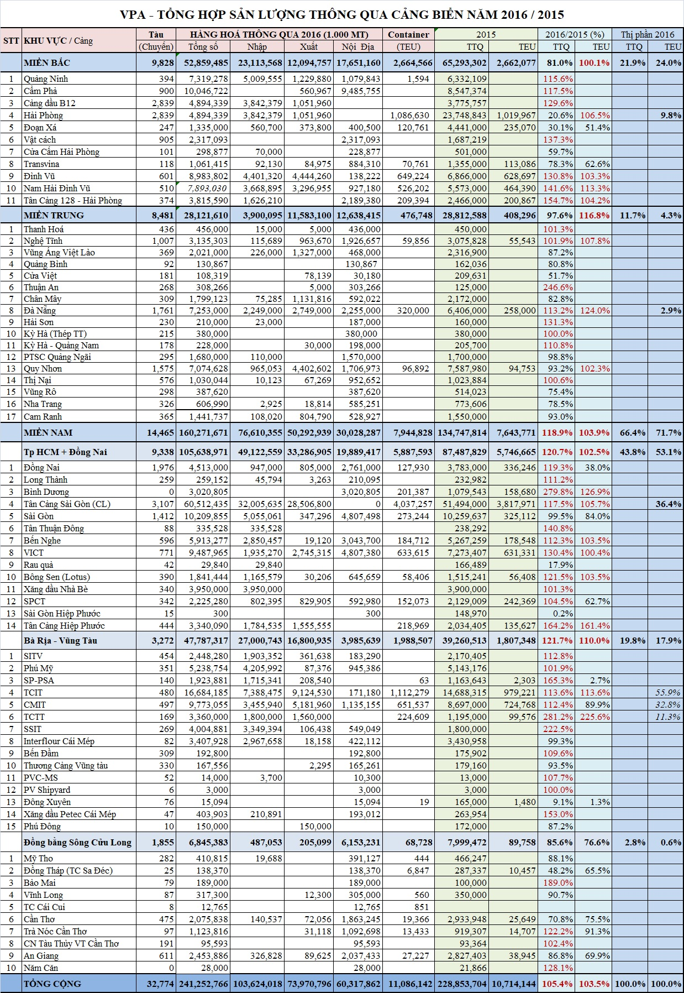

Annex 2

