VIETNAM SEAPORTS ASSOCIATION (VPA)
REPORT OF THE 8TH EXECUTING COMMITTEE
AT THE ANNUAL MEETING 2016
September 22, 2016 – Ha Long City, Quảng Ninh

GENERAL ASSESSMENT
Following the general assessment, the economic situation of Vietnam during 2015 - 2016 and beyond shall continue to develop at high growth rate with expectation on favorable changes brought about by the trade agreements being established. However, the global trade is not yet fully recovered within the scenario of developing risks from conflicts in many areas, in particular including Asia, the projection of growth is maintained at existing rate, by which, GDP growth rate is expected at about 6%, equivalent roughly to 10% increase in cargo volume through the ports in 2016.

Volume of import/export cargo through VPA ports in 2015 was about 234 million tonnes (15% increase compared to 2014), in which, container volume is about 11,1 million TEU (10% increase). Volume of container going through the ports in the first half of 2016 increased less than 2% compared to the same period last year. In general, global and regional shipping is slowing down affecting Vietnam but higher growth for Vietnam is realistic should there be no major unexpected disturbance. Under such environment, the situation of the ports in the country recently has some noticeable development as follows:

The ports have undergone the equitization period with changes in equity sharing, organization, management and operations toward higher efficiency under the competitive market mechanism. Many port enterprises have been listed successfully and had resources to additional capital investment for higher development. The port enterprises with controlling stake by the State have also been forced to follow the trend of reform to compete and develop. In particular, Saigon New Port has successfully developed many large port projects together with support service facilities country wide.

Cargoes going through the ports in three regions maintained high growth rate with the market shares occupied by the ports as follows. the ports in the North 29%, in the Central Area 12,3%; in the Mekong Delta 3,4%; in particular in port group no. 5 55%, in which 38.5% for HCMC and Dong Nai, 16.7% for CMTV area. In 2015, total cargo throughput increased by 15%, container by 10%.

In CMTV deep water port area, container volume in 2015 increased by more than 34%, in first half of 2016 by 48% YOY, while container going through the ports in HCMC area increased by less than 5%. The indication was that container is being attracted quickly to large container vessels in CMTV following the trend of alliance between shipping lines to use larger ships for cost sharing in collecting cargo at different market areas. However, transport connection, channel and limited throughput capacity of the deep water terminals as well as limitation of the supply chain of proper services for large vessels are the main restrictions still to be resolved.

In addition to containerized cargo, bulk cargo and other type of cargoes using larger vessels going through CMTV area have also increased significantly and accounted for half of the total 40 million tons of cargo throughput of CMTV ports in 2015.

In HCMC, from the beginning of 2015, the congestion in container and difficult trucking at Cat Lai port has exerted pressure for transition of container traffic to Hiep Phuoc area with Soai Rap channel being dredged deeper. However, the capacity to sustainably maintain and increase the depth of Soai Rap channel is yet to be determined coupling with the pressure to introduce larger feeder vessels for intra Asia trade has signaled the safer reallocation of container to the deep water ports in CMTV. HCMC is facing difficulties in assessing the scope and feasibility of the long term port development for the city, including Hiep Phuoc port group, following the market demand and development trend of the whole port group no. 5, through CMTV gateway port.

In Hai Phong area, although the market dimension is significant (more than 3 million TEU/year), but due to limited channel depth, existing large vessels of the shipping lines have not been able to put in use. In waiting for the Lach Huyen deep water ports, the ports in Dinh Vu area have seen high growth rate in container throughput, some ports at more than 20-40%/year. The whole port area in the North is requiring an overall management, coordinating mechanism for higher and more integral, sustainable development by competition on productivity, service quality with higher accumulation of capital for the development of the country gateway port.

In the Mekong Delta area, there have been many programs and projects to develop the system of transport infrastructure including ports and logistics services comparable to the economic dimension of the area with the capacity to accommodate large vessels to Can Tho port area for direct international trade. However, until now, international trade of the Delta area including the transit cargo of Cambodia still has to be shipped via the ports group no. 5, HCMC and BRVT.

One of the main issues of the ports of Vietnam is still to follow the mechanism of non-integral development of ports and hinterland infrastructure connections of channels, transport corridors and supporting logistics chains. Port master development following the 6 port groups is lacking of a mechanism for coordination and cooperation between the localities within each group to ensure the integrity and efficiency for the implementation of the master plan.

In parallel to the sea ports, the logistics services are gaining attention with effort from different sectors and levels and related organizations. Many enterprises have developed logistics services up to the national level but still relying on foreign global logistics services providers. There have effort to have more linkage, cooperation, policy lobbying to facilitate the development of logistics services, to reduce costs, increase competitiveness. However, the transition is still slow and the capacity to manage the development of logistics services which required high expertise, broader scope, higher integration is stumbling on hard-to-resolve inherent systematic weaknesses.

Foreign shipping lines have been applying non-transparent THC and other surcharges and exerted pressure on port handling charges undermine the development potential of sea ports and competitiveness of import/export commodities of Vietnam with the outside. The mechanism and regulatory capacity for international competition of shipping services in Vietnam market is not in line with the market demand and the administrative capability by region.

The Customs have had strong improvement on formalities, taking advantage of the ITC to facilitate online declaration, inspection by sample, post clearance inspection, introducing the national single window Customs administration portal. Improvements have promoted stronger development of foreign trade and in particular cargo throughput under the support of many international organizations following the orientation and requirements for trade development facilitation.

In general, there should be mechanism and break-through solutions to ensure integrity, inter sector and territorial cooperation in master planning and mobilisation of investment capital for effective and sustainable port development, with a view to protect the interest of the investors and sovereignty and also to meet the national strategic sea port development objectives.

In recent years the transport sector has exercised effort to overcome shortfalls, inconsistencies in the administration and development of transport in general and port in particular towards a more transparent and sound competitive market. The approach remains by seminars, soliciting opinions, agreement for the proposed changes, additions to current sector legislation system of centralized administration. The role and responsibility of the localities and other sectors in ensuring the integrity and efficiency of port development reform remains limited and hence it is hard to have major breakthrough solutions to the existing systematic shortfalls.

The Maritime Laws of Vietnam (as amended) have been ratified by the National Assembly in 2015 and shall become effective from 2017 have added provisions on port management bodies. Such mechanism has just been mandated by the Government to BRVT province as a pilot to implement such system with the objective to ensure the integrity in developing the national gateway, competing for transshipment cargoes, for the CMTV deep water ports. There are high hope that from such mechanism of breakthrough nature, the ports of Vietnam could create and complete a port reform system for more integrity and efficiency in port development with the role, resources and responsibilities of related stakeholders.

Together with above, the Association has had proposals to relevant authorities with specific opinions and recommendations.

STATUS OF THE PORTS

Port business and operations results
On the operations of the member ports, the statistics on cargo throughput of the ports during the period of 2010-2015 by areas are summarized in Annex 1 & 2.

The figures show the total cargo throughput of VPA member ports last year has increased by about 15% in tonnage and 10% in container. Cargo volume going through the ports in the South mainly in port group no. 5 continued to grow at higher rate and accounted for about 59% in tonnage and 70% in container country wide. Cat Lai port of Saigon New Port occupied more than 35,5% market share in container of the country with more than 3,8 million TEU in 2015.

In the North, Hai Phong Port has maintained highest throughput volume for many consecutive years and at more than 20% last year. Many other ports in the area also have had high throughput such as Cửa Cấm Port, Nam Hải Đình Vũ, Tân Cảng 128.

In the deep water port of CMTV, total container throughput reached nearly 1, 8 million TEU in 2015, an increase of 34% over previous year, with three terminals handling container namely CMIT, TCIT, TCTT in which TCIT occupied 54% market share and CMIT 40%. Throughput of TCTT terminal has been developed very fast. All above three terminals are attracting center of large container ships and expected to become full within the next few years.

In the Mekong Delta, cargo throughput in 2015 maintained the growth rate but with small scope (under 1% share of container market country wide) and at about 8 million tons, mainly domestic cargoes to be shipped via ports in HCMC area. Mỹ Thới Port had highest volume of container throughput in the Delta area, followed by Cần Thơ – Cái Cui Port, Trà Nóc – Cần Thơ Port. The Dinh An channel project through Quan Chánh Bố canal was assessed to remain an expectation to bring about big changes for the seaports in the West.

In 2015, cargo imported through VPA ports had the same volume as previous year at 73 million tons, import surplus remained at more than 12 million tons. Domestic throughput volume occupied a high percentage at 37% with about 82 million tons.

In 2015 around 65% of the ports have had higher throughput volume compared to the previous year (63%). Among 70 member ports, there are 4 ports having throughput of more than 10 million tons, 9 ports of 5-10 million tons, 22 ports of 1-5 million tons, on average one port handled more than 3,4 million tons/year.

PERFORMANCE EVALUATION

Major activities undertaken
In addition to the regular activities undertaken, based on the Resolution of the 8th Congress, the Executing Committee has provide guidance for the execution of some new tasks during 2015-2016, including:

- New tasks following the new Charter and as directed by the Ministry of Home Affairs;
- More participation in activities as requested by relevant authorities and member ports in settling issues in transport, port services such as floor rates for container handling at CMTV ports, shipping surcharges, container weighing following the Annex of SOLAS Convention v.v...
- Successful organization of the 8th Congress in Can Tho City;
- Supporting some member ports in developing international relations through APA programs, projects.
- Successful hosting of the 12th APA Sports Meet in HCMC with the consensus and financial support of the member ports.
- There has been encouraging results in the cooperation between some member ports in organizing, implementing the common activities of the Association, typically between Saigon Port and Saigon New Port in the successful organization of the 12th APA Sports meets in HCMC last May.

More details on activities are presented in the Secretariat Report.

Some main outstanding tasks
The main outstanding tasks, limitation of the Association could be mentioned as follows:

- The role of the Association in resolving common issues, difficulties ia still limited, particularly in the study, cooperation to stabilize the market, standardize port services quality.
- Implementation of the new Charter; development of associated non-port members. Beside, the Executing Committee should have met more often and appointing members in charge of specific activities/functions of the Association.
- There should be programs, activities nad measures to support member ports specialized such as bulk, oil and gas ports.
- Human resources development for ports could be done better, provision of technical information, materials, conduct of marketing trade promotion at Association level.
- Possible mobilization of experts, cooperators in the activities of the Association.
- Cooperation with other associations in resolving common issues, particularly issues of the maritime community v.v...

Although there have been certain achievements, the Association should be more active in implementing the provisions, objectives of the Charter, to meet the demand and specific requirements of the members.

In general, the Vietnam Seaport Association has conducted the plan of action effectively with the guidance and participation of the Executing Committee and member ports and also with the support of other organizations, individuals.

ORIENTATION, ACTIVITIES IN 2017
The Association shall continue to organize the better execution of normal activities and take effort and measures to better resolving the shortfalls indentified. To have plan and suitable measures including having specific tasks allocated to members in charge of the Executing Committee for achieving more effective results to the following:

- Carrying out more activities following the new Charter; particularly in inviting more membership; increasing the management capacity and efficiency in conducting the VPA activities with more participation from the ExCo and member ports including outsourcing as needed;
- Soliciting member ports to have opinions on orientation and master planning of port development, on port management mechanism following the Maritime Laws. Cooperating with relevant agencies to improve the market conditions; those are the main collaboration tasks of the Association;
- Promoting the relationship with other stakeholders, participating in giving opinions, recommendations to the authorities to facilitate the operation and development of ports, in supporting member ports in particular;
- Cooperating with the host port for successful organization of the Annual Meeting 2017;
- Maintaining and developing foreign relations. Active participation in ASEAN Ports Association (APA) activities. Hosting the APA Main Meeting 2017 in Vietnam under APA plan and following the rotational turn of VPA;
- Disseminating of information on training, cooperating with respective organizations to support human resources development of member ports;
- Consulting, preparing and applying standards on port management and operations efficiency, getting international location code for Vietnam ports, advocating the use of common port tariff structure and other port activity data elements to facilitate IT application, exchange of electronic information through single window information gateway for the community and country;
- Promoting the cooperation, exchange of information on line between the Association and the member ports, quickly resolving tasks using email;
- Investing in and developing more contents and services for the VPA website, for the publication of Shipping Times magazine, including the web-based version;
- Mobilization of experts inside the ports, particularly foreign experts at the JV ports, and outside to provide consulting services for port operations and management, including for dedicated liquid and bulk ports;
- Improvement of statistics and information updates for the ports, assessment of the market, port investment, operations and development, aiming at providing port development forecasts more frequent and in more details.
- Promoting more awareness and responsibility of sea ports in ensuring port facility security, protection of environment;
- Promotion of Corporate Social Responsibility between the ports and their communities, active participation in patriotic, poverty reduction programs; effective cooperation with the sponsor(s), firstly Stinis, to achieve the common objectives.
- Cooperation with related associations, bodies inland and overseas to resolve common issues,
- Considering possibilities to establish and provide services for development requirements in conformity with the Charter;
- Undertaking and completing well new tasks as needed.

Based on the above objectives, specific activities and budget for 2016 shall be presented and proposed in the Secretariat Report.

During the discussion, the Executing Committee suggests delegates to comment on the above contents including the tasks performed, the outstanding matters pointed out to provide basic requirements for the activities of the association in the years to come and in particular to have recommendations to the State and functional agencies.

On this occasion, the Executing Committee and all members are happy to welcome new members joining the association recently, namely:

- Quang Ngai Oil & Gas Services JSC (“PTSC Port Quảng Ngãi”)
New members are expected to participate actively and contribute to achieving the association objectives in the interest of all members and common interest of the country. The Executing Committee also wishes to have the joint effort of the members in getting more new members in the coming years to promote the Vietnam Seaports Association’s role and to have wider representation of the port business community in Vietnam.

RECOMMENDATIONS TO THE STATE AND MARITIME AGENCIES
Based on the orientation, policy and regulations pertaining to the ports of Vietnam and opinions from member ports, the association has some selected recommendations to be presented in the Secretariat Report.

The Vietnam Seaports Association expresses its thanks and appreciation to related Government agencies for the guidance and support extended to facilitate the completion of our activities and responsibilities in the past and wishes to obtain such continuous attention and support in the future.

CONCLUSION
Above are some assessment of the situation and some recommendations, specific activities for the coming given by the ExCo. Delegates are invited to discuss, give amendment, reach consensus and participate actively in cooperation for implementation.

On behalf of the ExCo and the Annual Meeting, I he artfully thank the Deputy Minister of Transportation Nguyen Van Cong, who has preserved his precious time to attend and give the Keynotes Address at the Main Meeting; my thanks to the dignitaries from the Government Office, the People’s Committee of Ha Long City, Quang Ninh province, Ministry of Home Affairs, Vietnam Maritime Administration, and functional agencies of the sector and province, our fellow associations, other organizations, the mass media for the kind attention and support extended to the association for its activities and development; my sincere thanks to the member ports for the trust and support extended to the ExCo and the Secretariat in tackling common matters and works of the association in the past. The strength of the association should be manifested in the capability to advice, to resolve important issues of the ports based on the foundation of solidarity and active participation of all member ports.

I sincerely thank the leaders of the People’s Committees of Quang Ninh province, Ha Long City and relevant agencies for providing excellent conditions for the association to hold its Annual Meeting in the City; my sincere thanks to the management of Cam Pha Port and the Organizing Committee for the excellent preparation, facilitation and support in all aspects for the success of the APA Annual Meeting 2016.

My sincere thanks also to the Sponsors of the Annual Meeting this year, including the Main Sponsors Liebherr Werk Nanzing GmbH, Kranunion GmbH & Co. KG, Amtecol and other sponsors Stinis Singapore Pte, Ltd., Unico Vina JSC, Konecranes Việt Nam, Terex– Noell Crane Systems (China) Limited, RBS, Siemens Ltd., Telin Technology & Infrastructure, among whom, many companies have had traditionally close and long term relationship with the ports as well as provision of continuous and valuable support to the activities of the association in the past several years. My thanks to the Editors and staff of Shipping Times magazine for the effective effort in publishing the special issue in commemoration of the VPA Main Meeting 2015. My thanks to the reporters from the mass media for the coverage of the event.

Distinguished guests and delegates.

The Vietnam Seaports Association has had 21 years of effective operation with the kind attention and support by the relevant authorities of different levels and areas and the active participation of all member ports, of many other organizations and persons. We have in fact created a firm foundation in many aspects for the successful execution of our tasks in the next term of office and next decade, a pivoting period of the history of industrialization and modernization with the maritime economy becoming one of the spearhead. The more important role and duties the association has, the more the members have to be active and pioneered for effectively contribution to the development of maritime sector and to participate in resolving common issues in the country and abroad relating to the ports.

With such evaluation and expectation, once again, I would like to thank all of you. My best wishes of very good health and success to our guests and to all delegates; success to the Main Meeting./

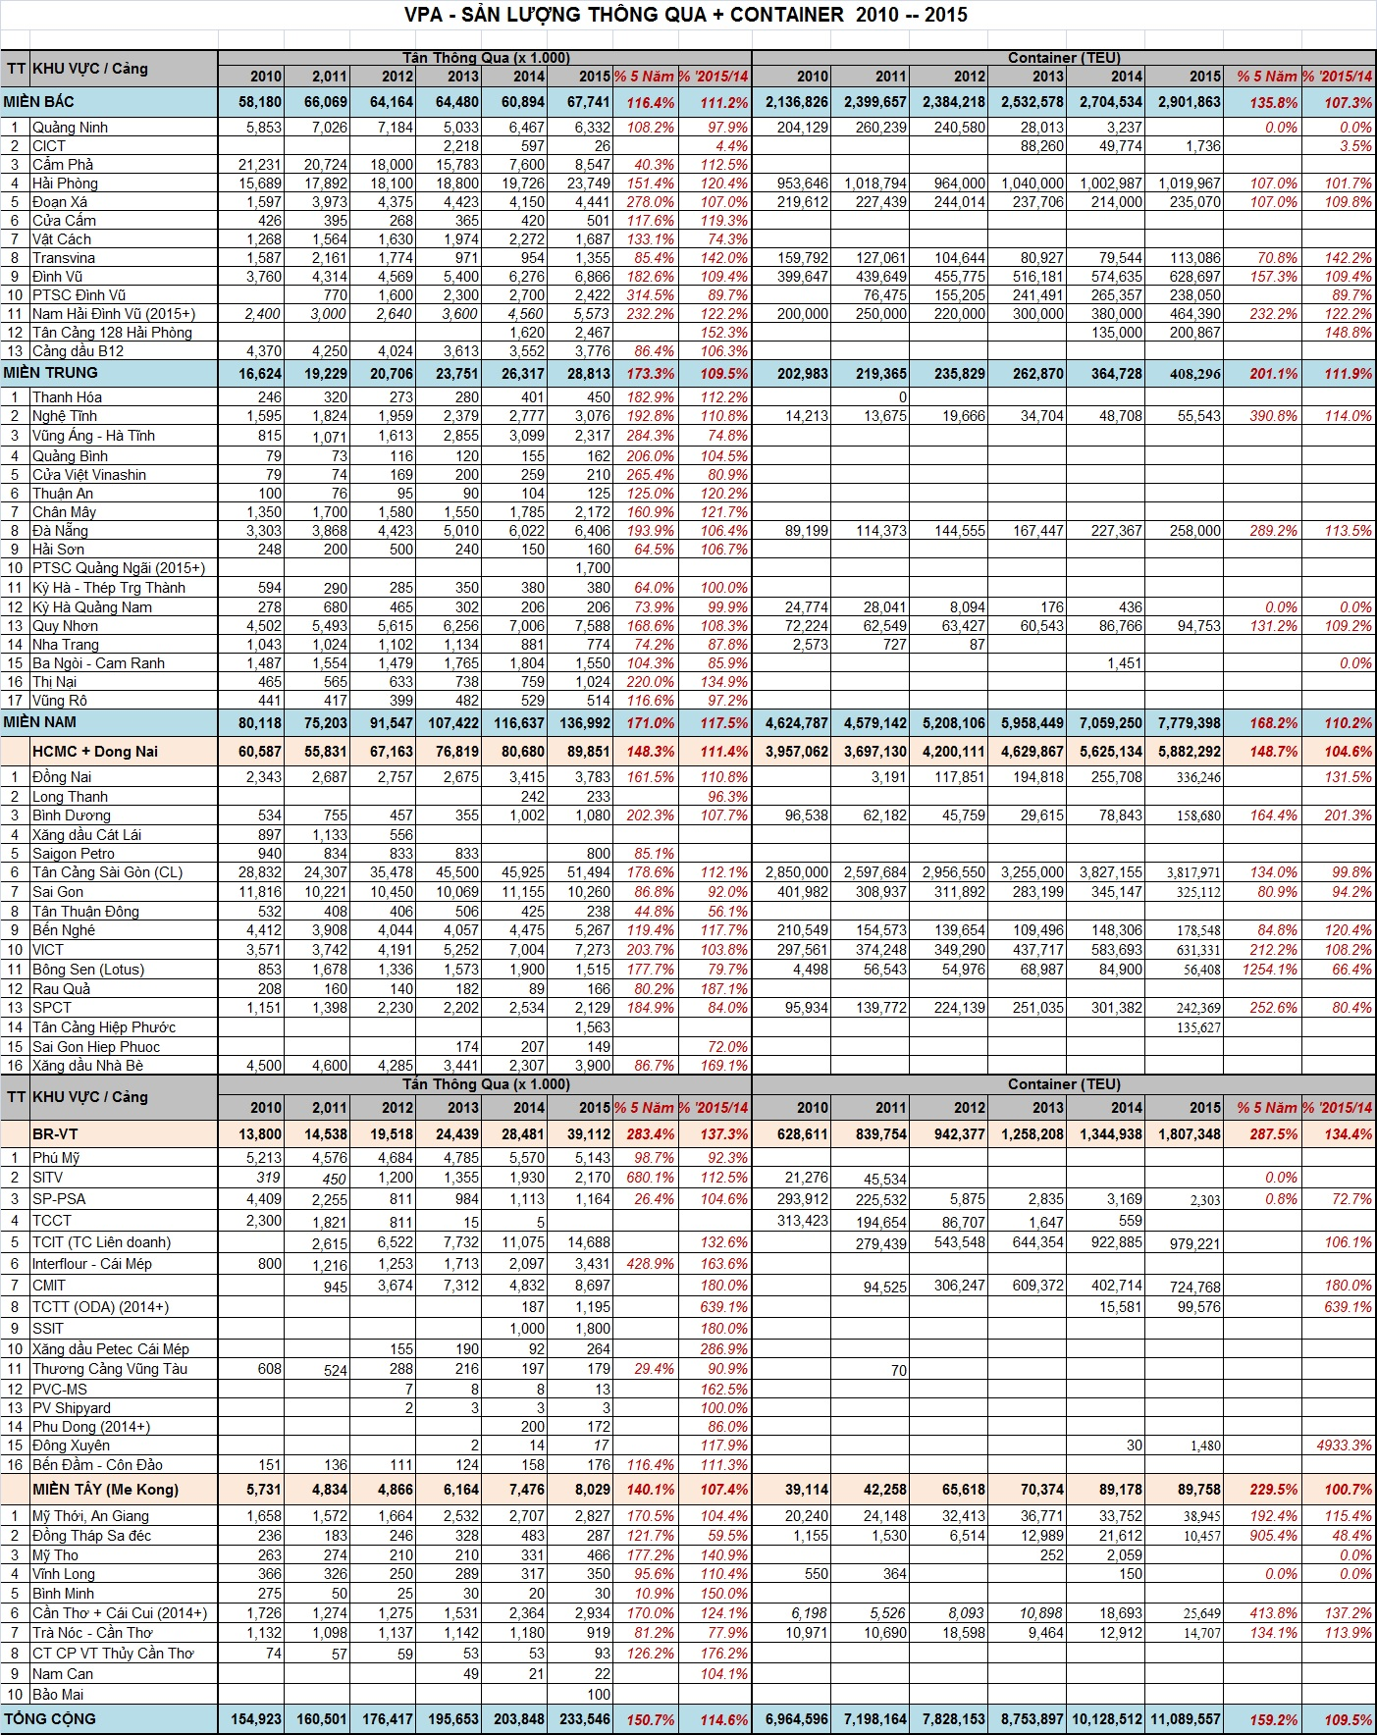
Annex 1
Annex 2
