VIETNAM SEAPORTS ASOCIATION
SECRETARIAT REPORT
At the Annual Meeting 2019
October 10, 2019 – Vung Tau City

Based on the program of activities for 2018-2019 as approved by the Annual Meeting 2018 in Cam Ranh City, the Secretariat has implemented last year activities with the results and evaluation given below. Further, based on the orientation and plan of actions for 2019-2020 as specified in the Report of the Executing Committee at the Annual Meeting 2019 in Vung Tau City, the plan of activities and the budget for 2019-2020 have also been prepared for the opinions and decision of the Meeting.

- Charter: the current Charter of the Association is the Charter as amended and promulgated by the Decision no. 132/QĐ-BNV of the Minister of Home Affairs on December 18, 2016. The provisions in the Charter allow entry of new membership including associated members who are not sea ports but have relationship and willingness to cooperation on a mutually beneficial manner with the Association. The approval of new member shall rest with the Standing Committee instead of the Executive Committee as previously specified. One new provision in the new Charter is that the representative of the member shall be decided by the member itself and not necessarily the legal representative of the member business entity.

- Organization, personnel: On the organization of the Association, the 8th Term Executing Committee elected by the 8th Congress has 17 persons (2 more members as compared to the 7th Term) including the Chairman and 4 Vice Chairmen and the General Secretary. The VPA Secretariat became the internal organization of the Association and currently has 4 members from Saigon Port, Hai Phong Port, Ben Nghe Port and Saigon New Port. Under the general management of the Chairman, the VPA Office is staffed with 2 permanent employees and 1 part time employee working at the office space rented from Saigon Port.

- Member: Currently the Association has 74 members who are sea port enterprises; including 24 state-own enterprises undergone equitization (38%), 10 JV enterprises with foreign investment, 6 private ports. Member ports relocated and terminated operations include Cat Lai Oil Terminal, Song Han 9 Terminal, Nguyen Van Troi Port. Member Ports solicited membership suspension due to various reasons include Saigon Petro Port, Cai Lan (CICT) Port from 2015, Dinh Vu PTSC Port from 2015, Thanh Hoa Port from 2019. Amongst which, Cai Lan CICT Port has officially opted to resume its membership since Oct. 2019.

During the period 2018-2019, the association has had 5 new members:

- Nam Đình Vũ Port
- Gemadept Dung Quoc Port
- Hao Hung, Quang Ngai Port
- Phuoc Long ICD midstream Port
- Tan Cang - Cai Mep Thi Vai (TCTT) Port

Actually, most of the main seaports of Vietnam are already members of the Association. Nevertheless, considering the number of river terminals capable of receiving sea-going vessels and other entities having business relationship with sea ports, there are still a large number of potential new members, particularly associated members, to join the Association. In respect of cargo throughput, member ports are handling around 60% of country total volume in tonnage and about 90% of total container volume. Most of the remaining throughput include bulk, liquid cargo volume going through cement, fertilizer, clinker dedicated terminals, oil factories and off shore crude oil exploration output.

- Membership fee: to date, most (68/71 of member ports have contributed membership fee of 2019 based on the new membership fee scheme as proposed by the Standing Committee and approved by majority of member ports, though the fees are considered rather high for many member ports having encountered difficulties in business operations. Member ports have in fact trusted and supported the Association for its role and capability in contributing to the common cause of port development; by funding various activities of the Association, including to meet the commitment in international relations and to conduct many other concrete tasks in the best interest of member ports, to support the reform, development of the maritime subsector and the national economic development more effectively.

- On the port management and operation efficiency, in 2019, the VPA Office has started the collection of container statistics on a monthly basis provided by member ports handling container, showing YOY growth rate. The initial results were encouraging in assisting member ports with uptodate performance vis-à-vis market development; and also in providing relevant users, including international consulting firms in keep abreast of ports development in Vietnam. In the near future, VPA shall solicit support from member ports in providing statistic information, practical experiences and insight for deeper assessment and recommendations on improvement of productivity, quality of port operations based on international performance indicators, and if possible, those indicators on green port, ICT application, ecommerce, 4.0 technology in port operation and business.

- Activities of the VPA affiliates: Shipping Times Magazine had maintained its operations despite limited manpower. In the past, the magazine has obtained regular support by many member ports. However, to have better condition for development, the magazine would need additional support for more regular publication with more comprehensive and specialized contents to meet the demand of member ports and the maritime community at large.

The VPA website has just been redesigned with new features and accessible using various devices including mobile phone. VPA office is planning further upgrades with additional information and applications providing more contents and services to member ports and the community.

- Consulting and recommendation to the sector and State

In recent years, the Ministry of Transportation and the Maritime Administration have had great effort to resolve issues arising from the market relating to sea ports. The VPA Office, together with member ports, has had many opinions, recommendations on different maritime legislative issues as requested, including:

- Port business operation requirements
- Increase the efficiency and competitiveness of the deep water ports
- Customs legislation in ports
- Resolution of overdue cargoes in ports
- Floor rates for port handling service and port charges
- Location for dumping of channel and annual alongside dredging materials
- Port development in the Mekong Delta
- Mobilization of capital investment for logistic infrastructure development..
- Port development management body

In addition, other agencies such as Finance - Customs, Planning & Investment, the Vietnam Chamber of Commerce (VCCI) and some local agencies have requested our opinions on other draft legal documents relating to port development master planning, business conditions, maritime trade, trade facilitation, economic integration following the international free trade agreements, conventions ratified or contemplated by Vietnam. In particular, the Government Office has recognized recommendations of the VPA regarding the development of port infrastructure, competitive market and has demanded VPA to actively participate in achieving the targets of the sector. In foreign relations, international economic integration, VPA has also obtained guidelines and approved annual plan of activities from the Party Central Agency for Foreign Relations.

It can be said that never before had there been continuous and extended effort in amending the legislation system in general and maritime legislation in particular by related agencies in recent time, with the consultative role of the associations. However, till now, many of the opinions, recommendations by VPA in general and by member ports in particular have not yet been considered and resolved on time by various reasons.

Based on the recommendations proposed by VPA in 2017 and additional opinions of some member ports, the VPA recommendations to relevant authorities on the occasion of the Annual Meeting this year are included in the Meeting document and to be submitted to relevant authorities.

- International Integration.

This year, following the plan as approved by the Party Central Agency for Foreign Relations, VPA shall send delegations to APA meetings such as:

- The 40th APA Working Committee Meeting in the Philippines in September 2019 (2 delegates)
- The 13th APA Sports Meet - Technical Meeting hosted by Indonesia in JogJakarta in October, 2019 funded by VPA with the contribution and support by Saigon Port and Saigon New Port.
- The 45th APA Meeting in Cambodia scheduled for November 2019

For the next year 2020, in addition to the annual APA regular activities as above, it will be VPA turn to host the APA HRD Seminar in Vietnam in the 2nd Quarter, the APA Working Committee Meeting in the middle of the year; and particularly to appoint representatives to assume the APA Vice Chairmanship, APA Honorary Auditor for the 2020-2021 term of office; For the following term of 2022-2023 to appoint APA Ciarman and APA Secretary General. Thus, in the coming years, Vietnam shal assume the key role and responsibility in the activities and development of the whole ASEAN port groups.

In addition, under the policy and guidelines of the Executive Committee, VPA shall have its international relations promoted and shall participate actively in cooperation, connectivity activities with the ports in APEC area to be well informed and to carry out the cooperation programs between the ports in Vietnam and those in the region and internationally under the Free Trade Agreements (FTA) frameworks.

- Corporate social responsibility. To date, corporate social responsibility of the Association has obtained full support from the Executive Committee and member ports and become the regular undertaking included in VPA plan of activities and annual budget. Beside the donation of 60 million VND to support the building of shelter for one poor household in the province of the host port this year, VPA together with the traditional sponsor Stinis have agreed to contribute 140 million VND to support 17 poor households in Ba Ria - Vung Tau province, in which 60 million to build one new house of solidarity and 80 million Dong to support 16 households each with 5 million Dong for having additional means for cultivation, farming.

- Financial Report from August 1, 2018 to July 31, 2019 is presented in Annex 1. Followed by the separate book keeping Financial Report of Stinis Charity Fund as Annex 1b. Comparing to the Budget, the actual spending of the last fiscal year has large unspent budgeted item of about 300 million to conduct new activities. On the other hand, new cost items incurred to cover the new activities in international economic integration in 2019 to select, form a contingent of athletes for participating in the 13th APA Sports Meet in Indonesia with the generous support from Saigon Port and Saigon New Port. It should be well noted that the Association is much better off than other associations in conducting its activities thanks to the effective support and contribution of the member ports, the traditional sponsors and in particular the precious contribution of Stinis for the corporate social responsibility of the ports of Vietnam.

- Budget for 2019-2020 for the activities of the Association mentioned in the report of the Executing Committee is prepared as Annex 2 for the consideration and decision of the Meeting; in which, in addition to the budgets projected for the regular annual activities, there are provisional budgets for developing the new activities such as ICT applications, subject studies and particularly budget for implementing the works of the task groups under the direction of the responsible Executive Committee members; the budget for the IX Main Meeting and particularly budgets for hosting the APA HRD Seminar and APA Working Committee Meeting in Vietnam; travel expense budget for the APA officials appointed by VPA to participate in the APA meetings overseas, if any.

In addition to the activities mentioned, we expect more participation of the Executing Committee and the member ports in the activities to be performed by VPA. It should be mentioned that until now, there have been many the functions, duties of the Association following the Charter are still pending due to lack of capacity and participation.

In conclusion, with the above summarized presentation of the main activities to be conducted for next year together with the proposals by the Secretariat, we expect he Executing Committee and the Meeting to consider and give specific opinions and decisions. Member ports are also proposed to participate more actively in supporting the Secretariat to carry out successfully the plan of actions of the Association in the year to come with the objectives to meet the increasing demand and requirements of member ports.

On this occasion, the VPA Secretariat would like to thank the agencies, organizations and individuals within and outside the association for the trust and effective support extended to VPA Office to facilitate the execution of our duties and tasks in the past. We expect receiving the same in the future and together with more effective collaboration and cooperation.

Thank you and best wishes of good health to all and success to the Meeting./

Annex 1A

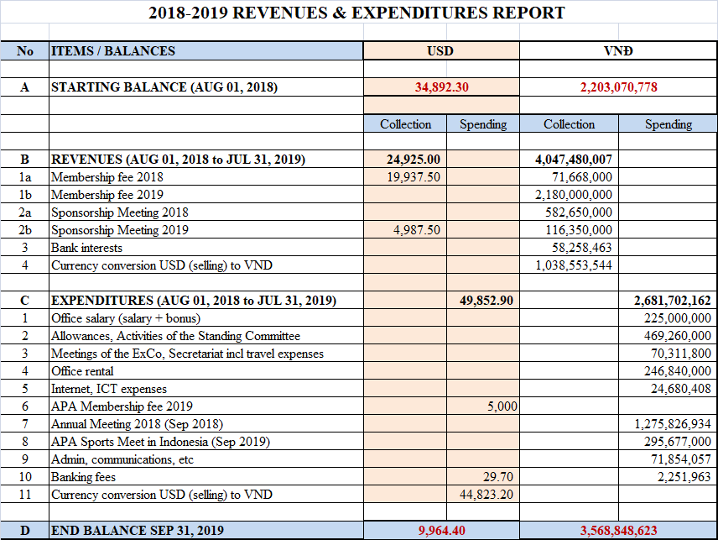

Annex 1B

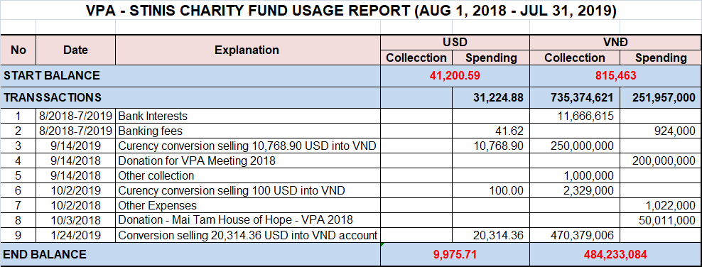

Annex 2
